  - Designdocument

PartnerPortal WorkOrder Flow

Versionshistorik
Dato | Version | Forfatter | Handling
2025-01-16 | 1.0 | PAHEH | Created Document

Indholdsfortegnelse

1 Purpose 2

2 Case number for Epic or Story 2

3 Description 2
1.1 Overall 2
1.2 Requirements 3

4 Existing setup 3

5 Documentation 3

6 Database 3

7 UI 3

8 What should be coded 3

9 Knowledge 4

Purpose
The original communication endpoint (Installationsblanket.dk) will be closed sometime this year. (July)
This project will be about creating a new API that will be used as a substitute for the old one.
The new API should be created at the PartnerPortal.
This document contains information on the API communication ONLY.

Case number for Epic or Story
-Add case number here

Description

Overall
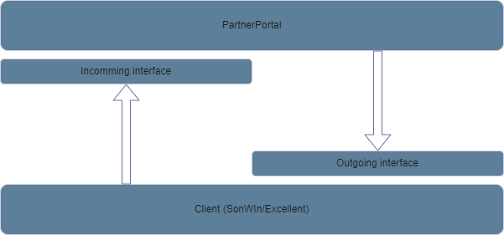
The development of the new solution should reflect the existing flow from the InstallationsBlanket.dk.
The reason for this is, that there are multiple clients using this solution today (Excellent and Sonwin)
The solution as it is today consists of 2 SOAP interfaces that are used for communication between the client and the API. (Client meaning at the usage end (SonWin/Excellent, API Meaning at the Installationsblanket.dk side).
The interfaces are used for receiving data from the other end, hence having the responsibility of communicating only one way.
The diagram above shows how this works. Be aware that the naming is done from the view of the PartnerPortal (API side)

Requirements
The following section contains information on the technical requirements for the solution (v1).
- SOAP communication
  - 2 separate interfaces
    - The API should expose a soap interface for communicating inward
    - The API should be able of dynamic SOAP interface consuming, for communicating to the clients in the outgoing flow.
- HTTPS setup
  - The current connection from the existing clients is made with HTTPS hence the new solution should also be.
- Authentication
  - The current solution is made with BASIC authentication. In the first versions we have to keep this configuration, as it is a decision made from above, that the clients should be able of shifting directly (If possible)

Existing setup
The existing setup from the clients to the API is very important.
The focus should be on as less changes to the clients as possible due to the fact that the flow is stable now but is a very complicated flow on their side.

Documentation
Which types of documentation should be created/maintained:
- Information on how to setup the system
  - Information for customers outside our organization
  - Information for internal resources
- Technical documentation for developers

Database
The solution will have a database on its own.
(Johan will you provide details here)

UI
The UI will be a webpage on PartnerPortel.
The UI is handled in another project hence not in this design document.

What should be coded
- Incomming communication
  - Implement SOAP interface in PartnerPortal API
- Outgoind communication
  - Extend PartnerPortal with communication engine for outgoing communication
  - Extend PartnerPortal with configurqation for the outgoing communication details

Knowledge
Who to contact on certain issues:
- Architecture
  - Johan Lange
- SOAP interface
  - Paw Hauge
- Test environment
  - Jesper Berner Haarden

