Host Project from Visual Studio.
Step 1:
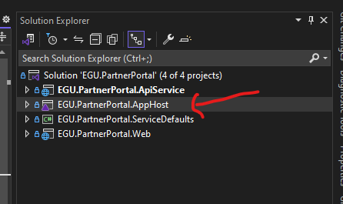
Step 2:
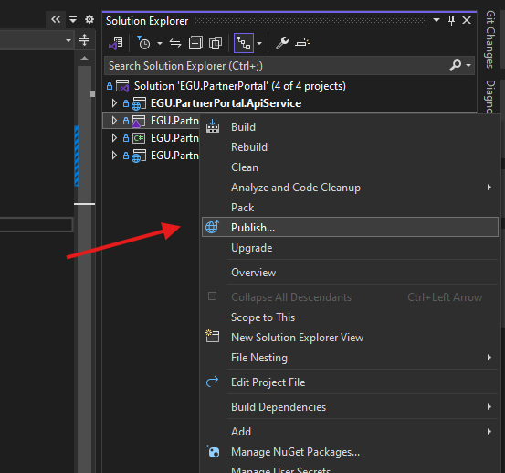
Step 3:
Environment name: - Resource Group
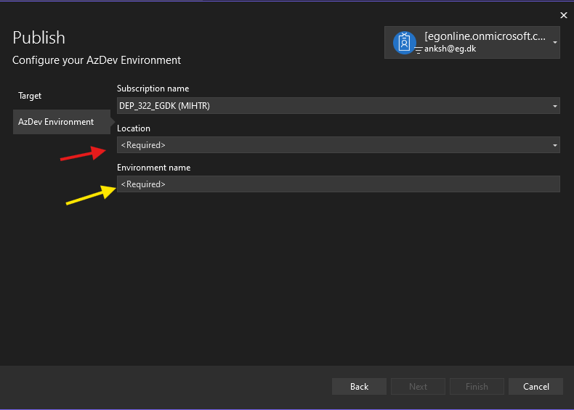

Step 4:
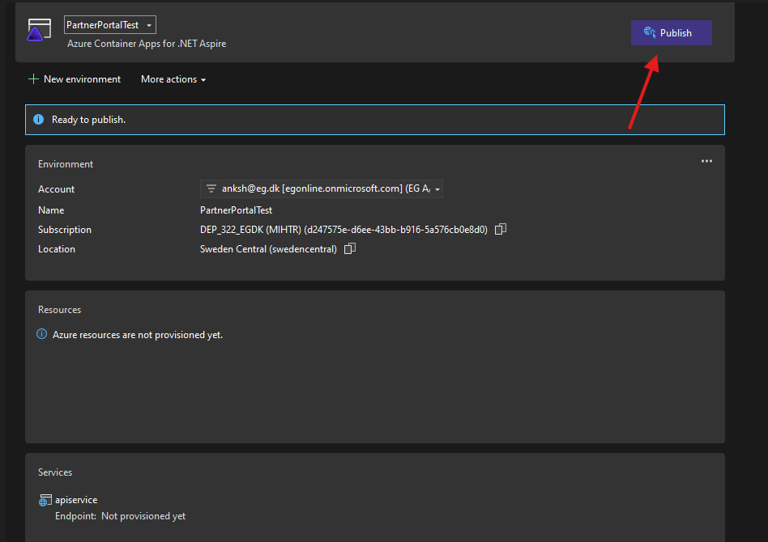

Step 5:
After clicking publish tab you can check on output window
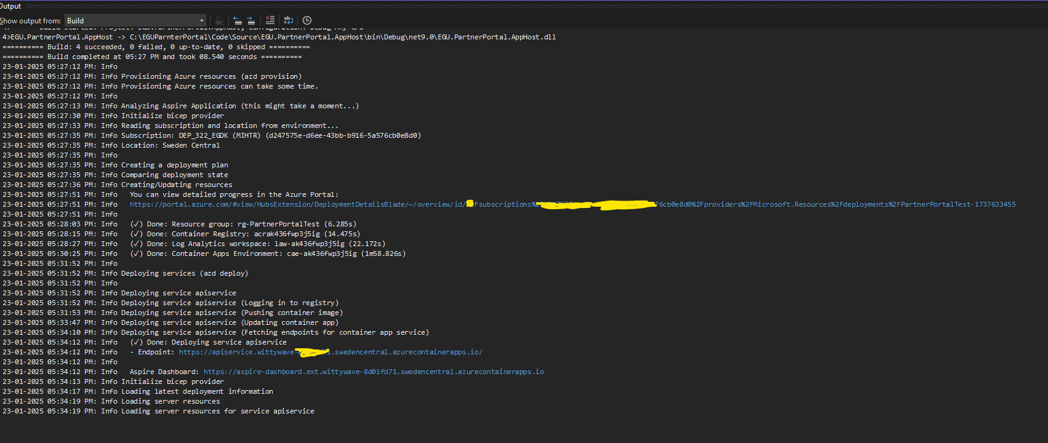

Step 6:
