Need to request Jesper to provide subscription access for your ID
Step 1 : Login to Subscriptions - Microsoft Azure
Step 2 : Choose the account ex : navra@egcops.micorsoft.com – Not EG ID
Step3: You will navigate to below page
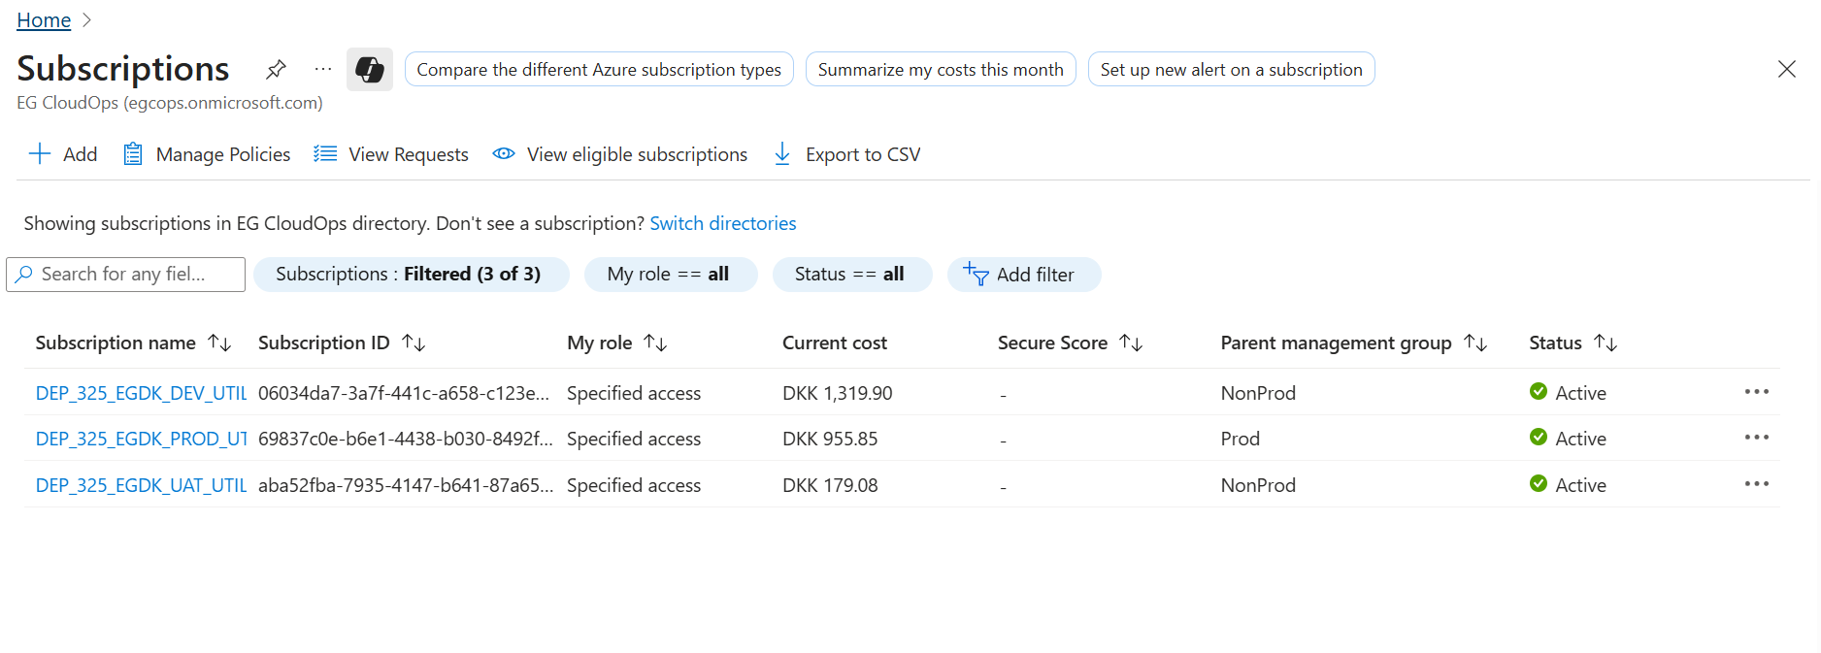
Step 4: Click on DEP_325_EGDK_DEV_UTILITY (AXSUN) – this is for both DEV and TEST environment – Below page gets loaded
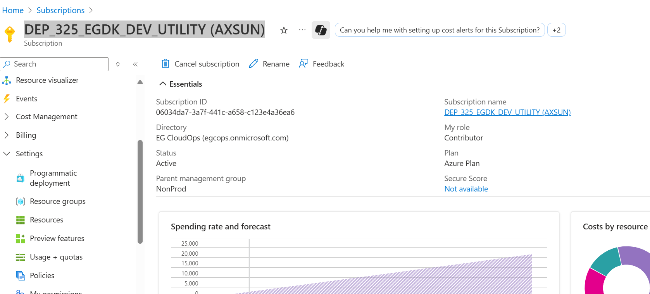
Step 5 : Select the Resources
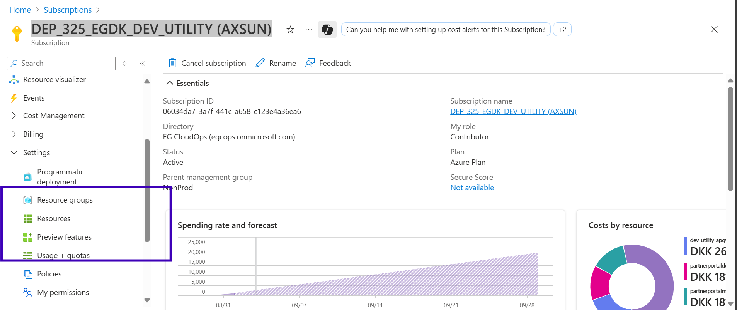
Step 6 : Click on SONWIN-PP_TEST – if using dev then select Dev ex : SONWIN-PP_DEV
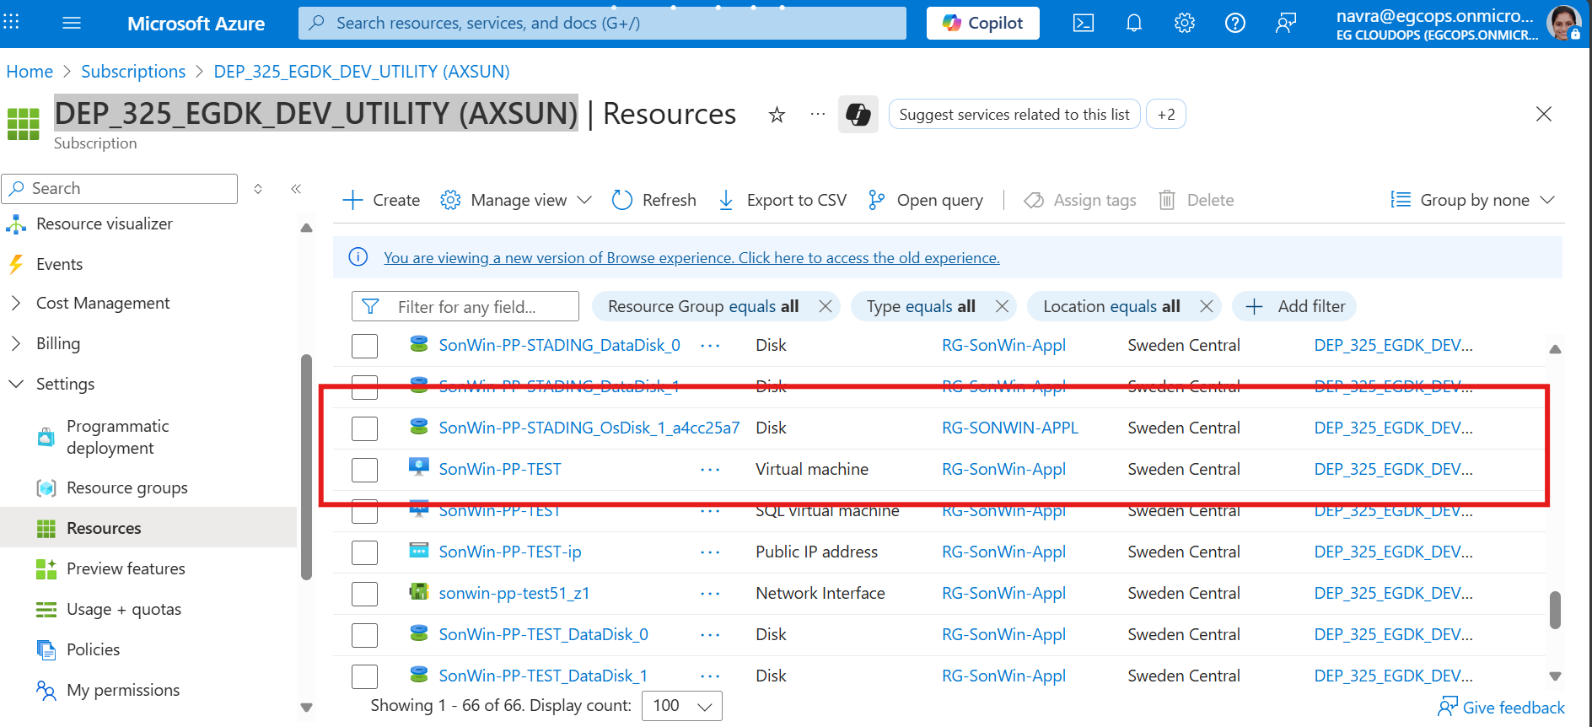

Step 6 : Click on connect
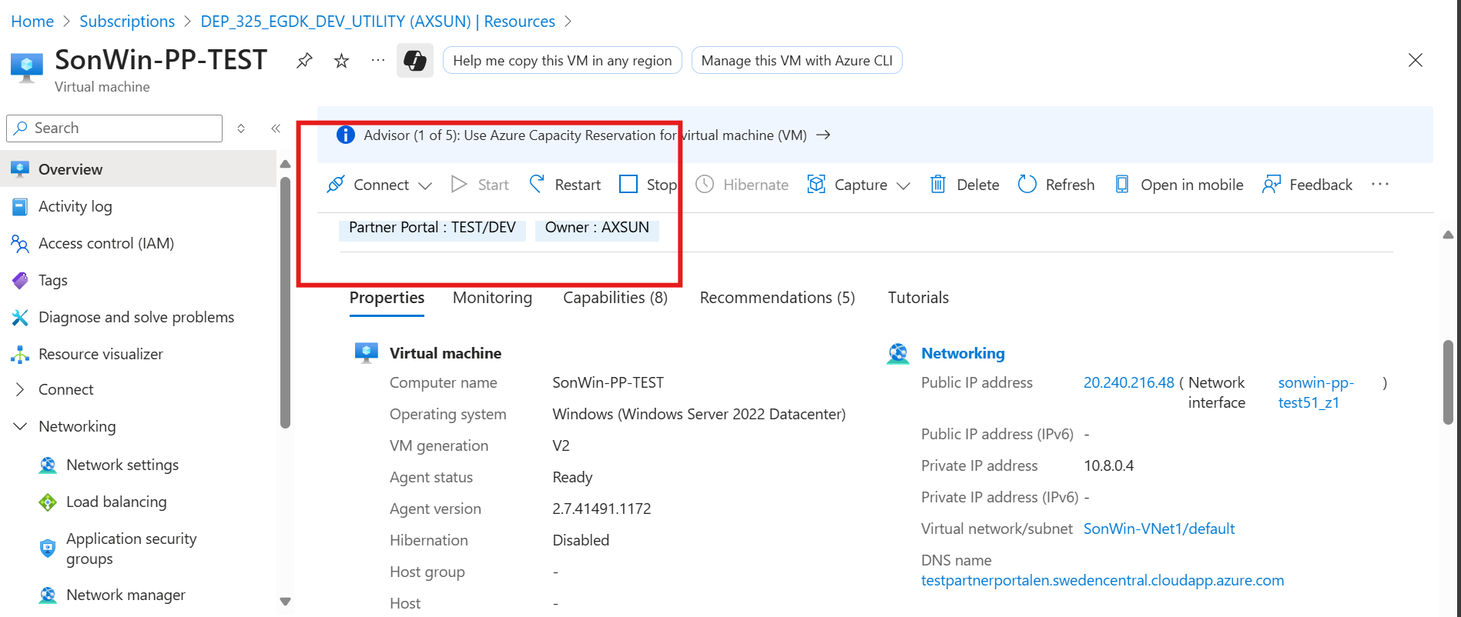
Step 7 : Below rdp file gets downloaded
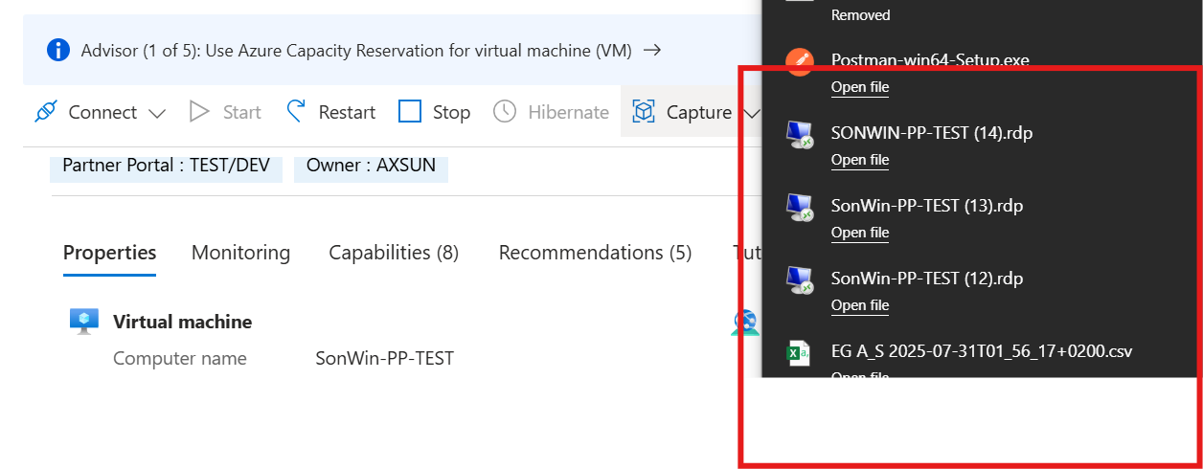
Step 8 : Click on open file
Step 9: Below pop up will open and Click on connect
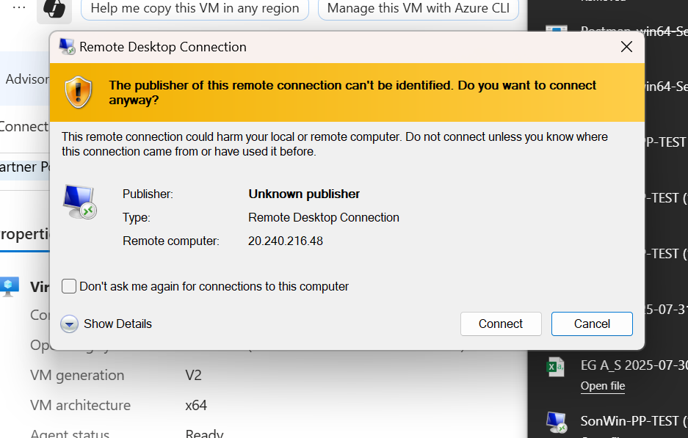
Step 7 : Can login with any of these ID's
Login User Acount Name: SonlincAdmin - PassCode: Effing0ys0n!2021
Login User Acount Name: SonwinNova - PassCode: n2UzgvsN1tzAg9NkRvUo
Step 8 : Click on Sonwin Billing : Need jesper to create username and password for the same
Username :
Password :

