Login As Contractor User/Contractor Administrator:
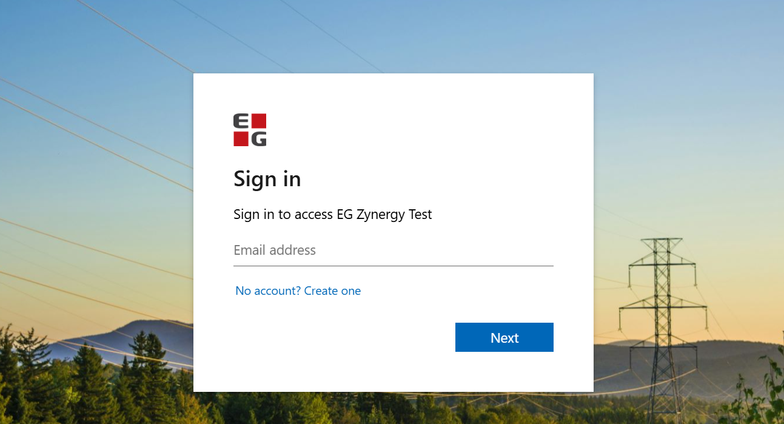
Soon after login – Overview page is displayed
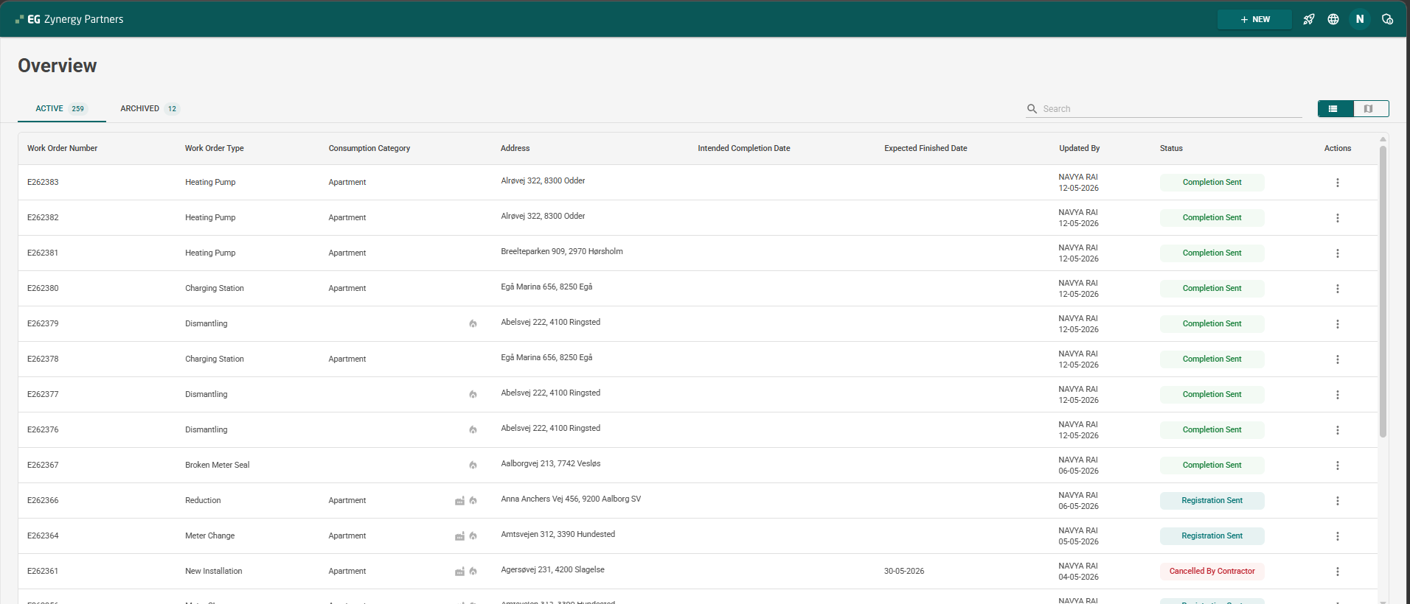
If the contractor already has the record – in overview page set of records gets displayed, else the overview page displays – "No Work Order"

Click on Expansion – On the right corner [Refer the Image]
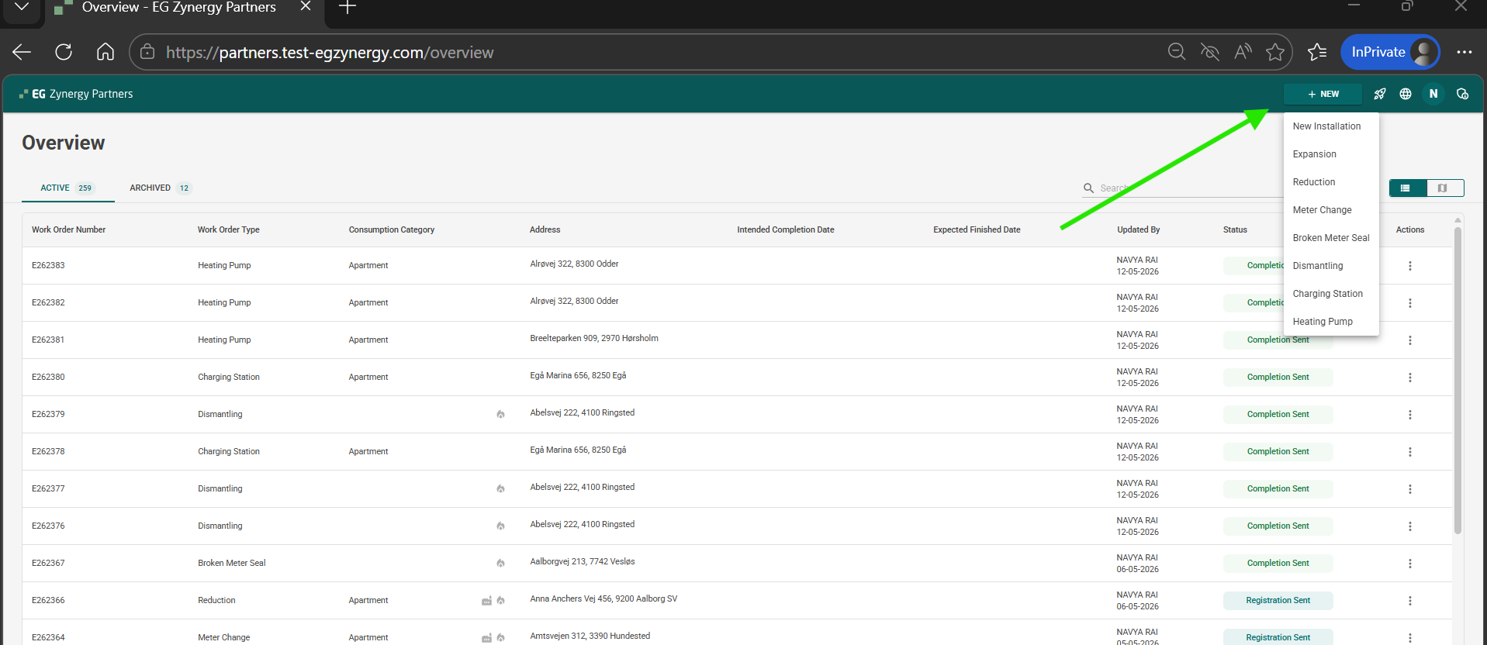
Select the form which user wants to submit the request
Ex: Select the New Installation Form
New Installation Registration Form gets loaded
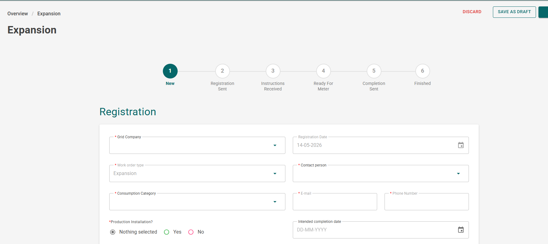
Fill in the details [Can fill the minimal details and save the form for later use]
Grid Company
Contact Person
Production Installation
Note : User can fill the minimal information of the form and then can click on Save as Draft
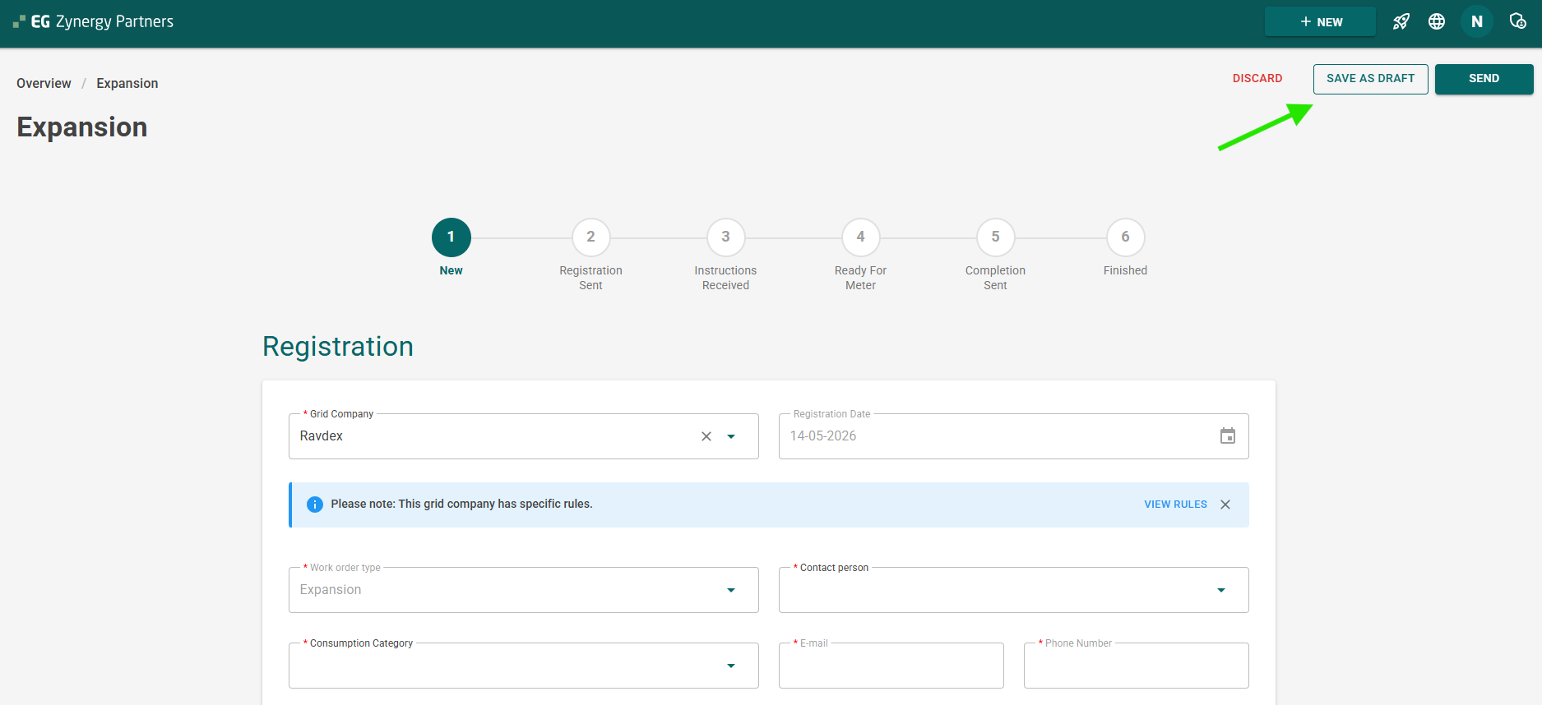
After Click on Save As Draft – "Your workorder has been successfully saved as draft" message is displayed
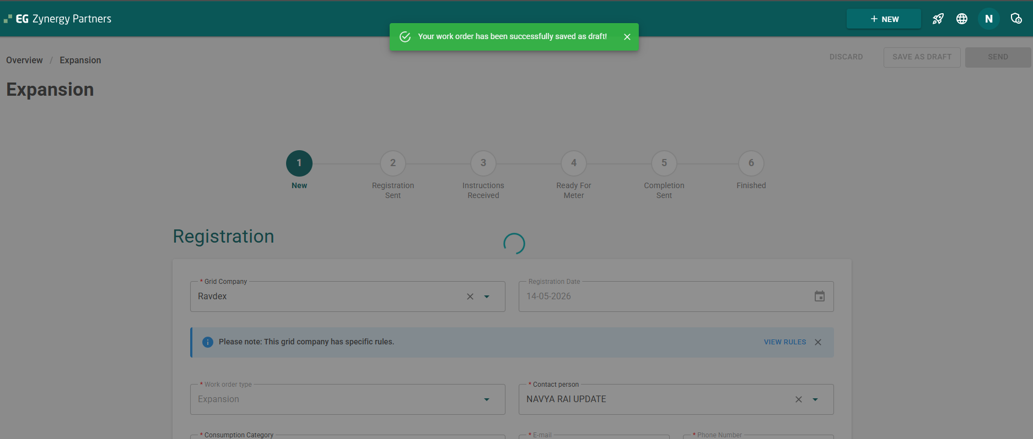

Once work order saved successfully – Work Order Number gets generated and work order will be in the draft status [As shown in Screenshot]
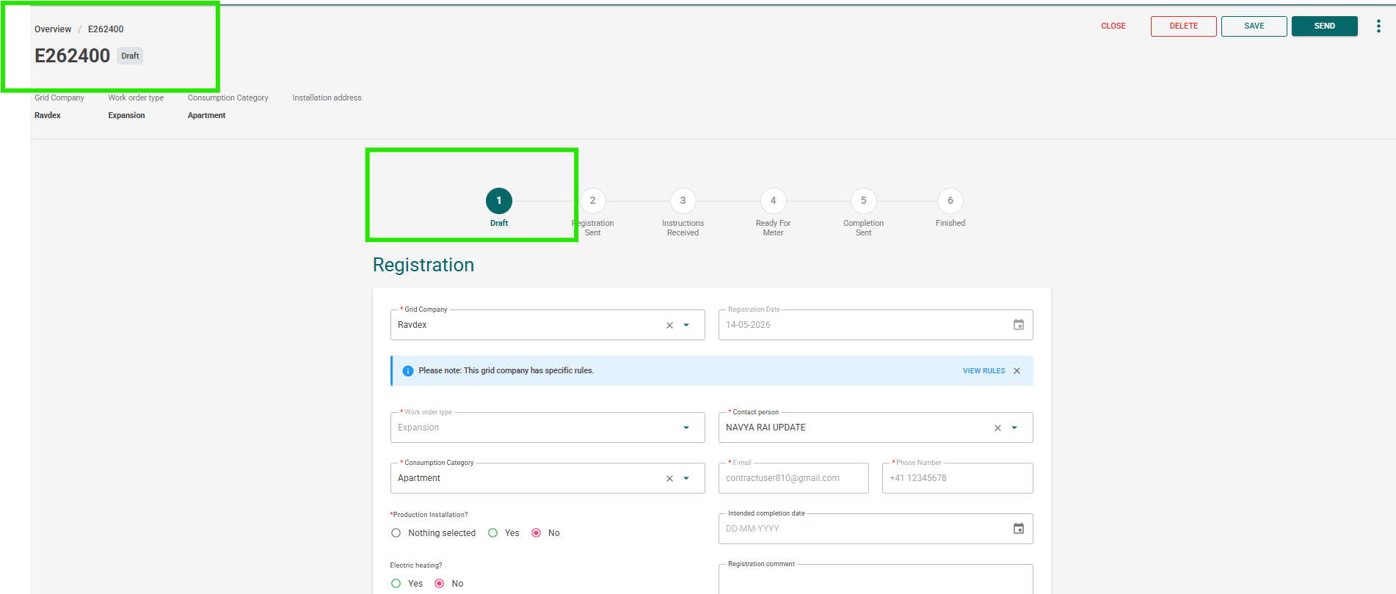
User can close the form by clicking on Close button on the right side of the form
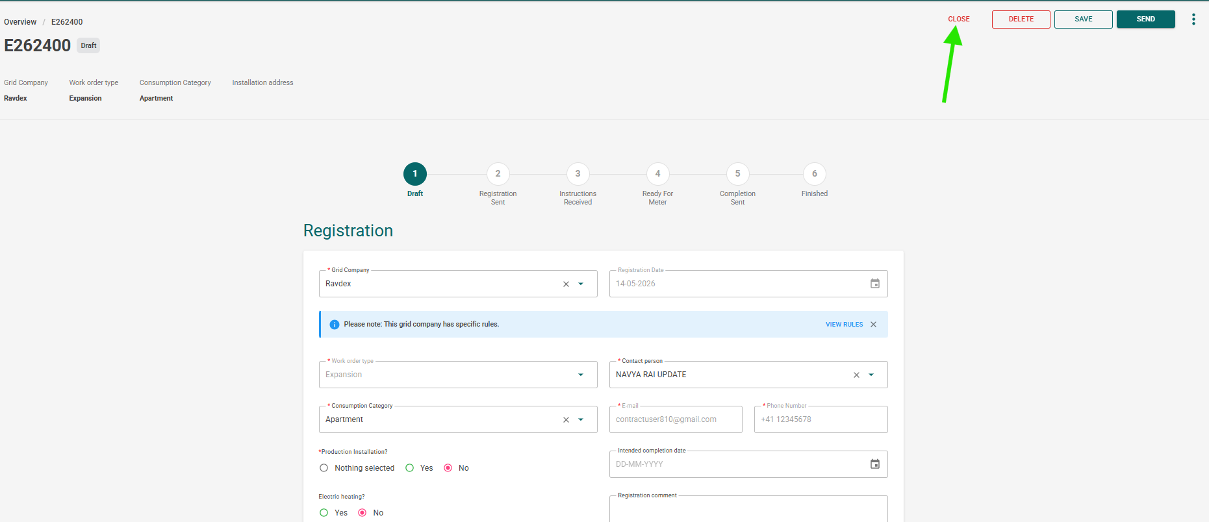
After closing the form – Overview page gets displayed and latest created work order gets displayed at the top
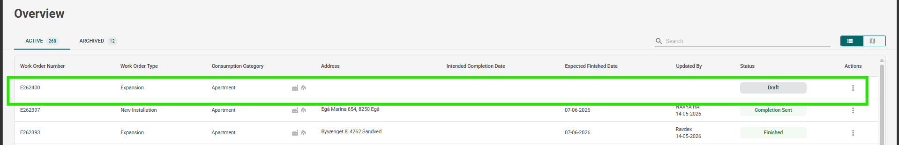

If user wants to submit the form – Click on workorder number or user can perform the search by providing the work order number -> then click on the workorder number
After clicking on workorder Work order form gets displayed Fill in all the details to submit the work order request
INSTALLATION ADDRESS SECTION
Case 1 : User can enter the address using search criteria (As shown in screenshot) or can input the details
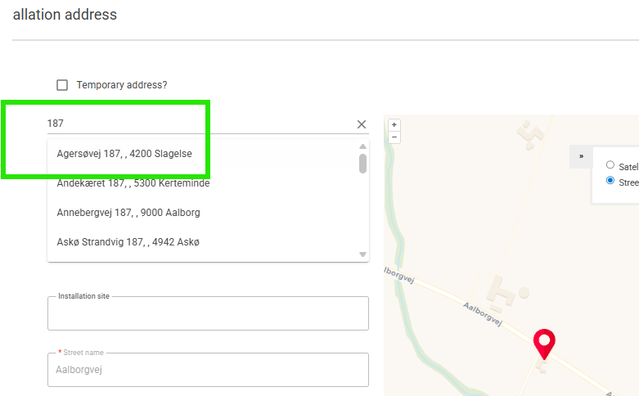
Based on search details gets displayed and select the valid address from list Address gets fetched and displayed under the installation address section
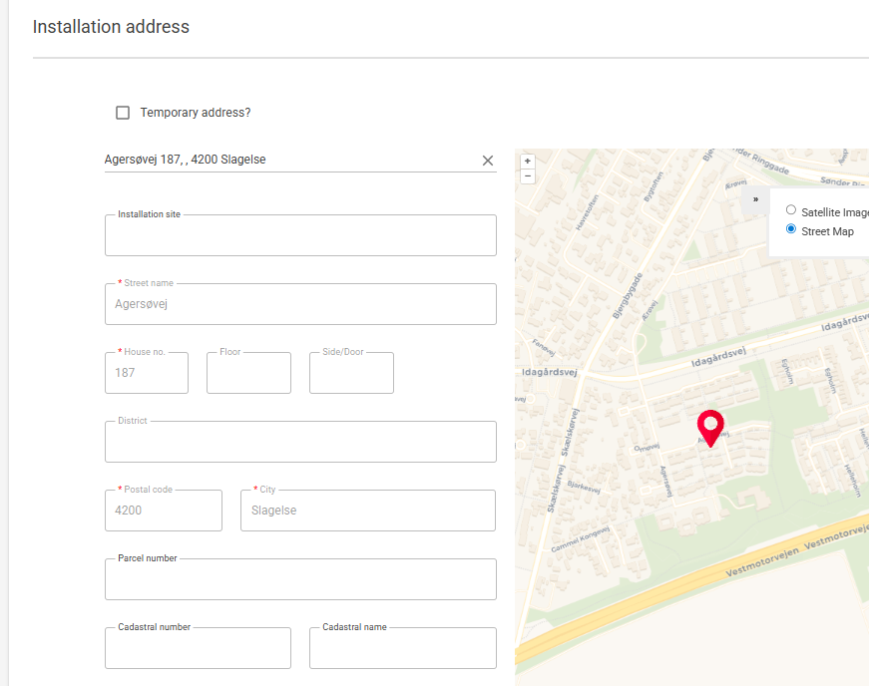
Case 2 : If user wants to enter his temporary address – user can click on check box and enter the address details
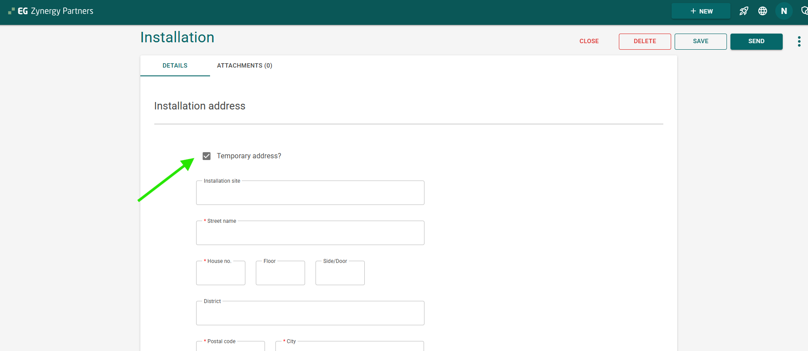
CONTACT PERSON FOR INSTALLATION:
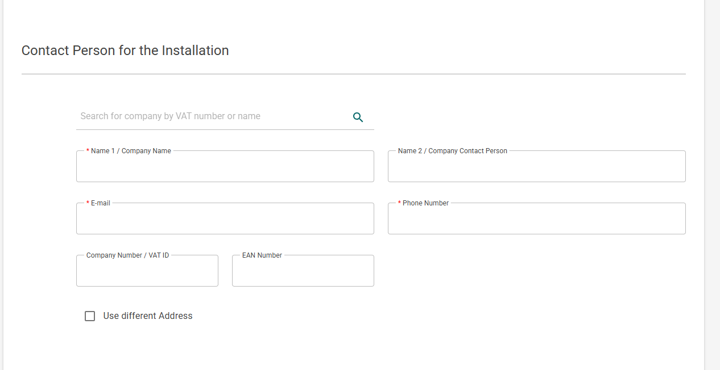
Search the company by VAT number or name -> Enter the company number or name – Select the valid data
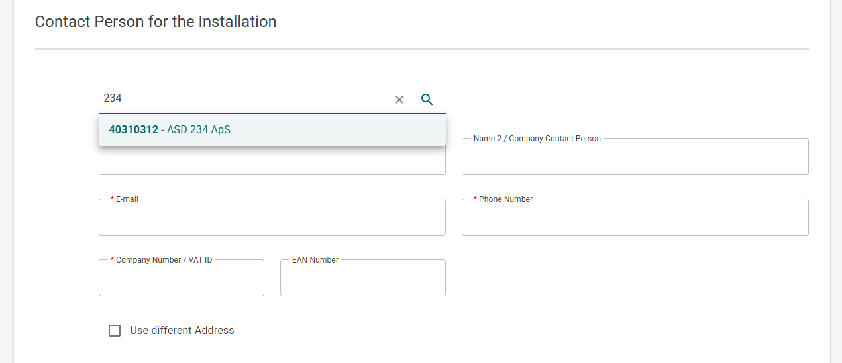

Pop-Up will display – asking the user to update the contact person address with CVR address or to update the 'Connection Fee Paid By' address with CVR address. 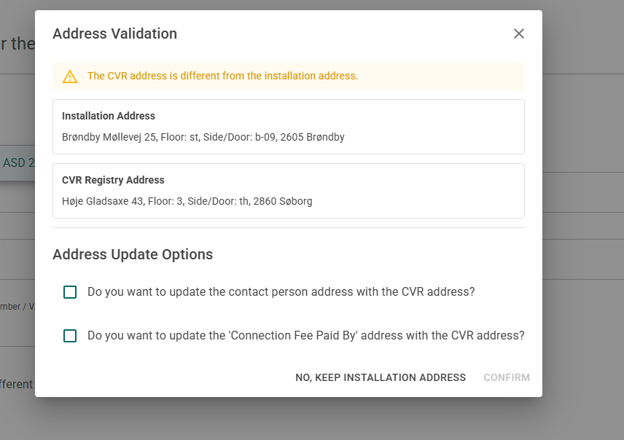
Select the appropriate option and confirm
// User can also enter a different address if they have one – check the checkbox
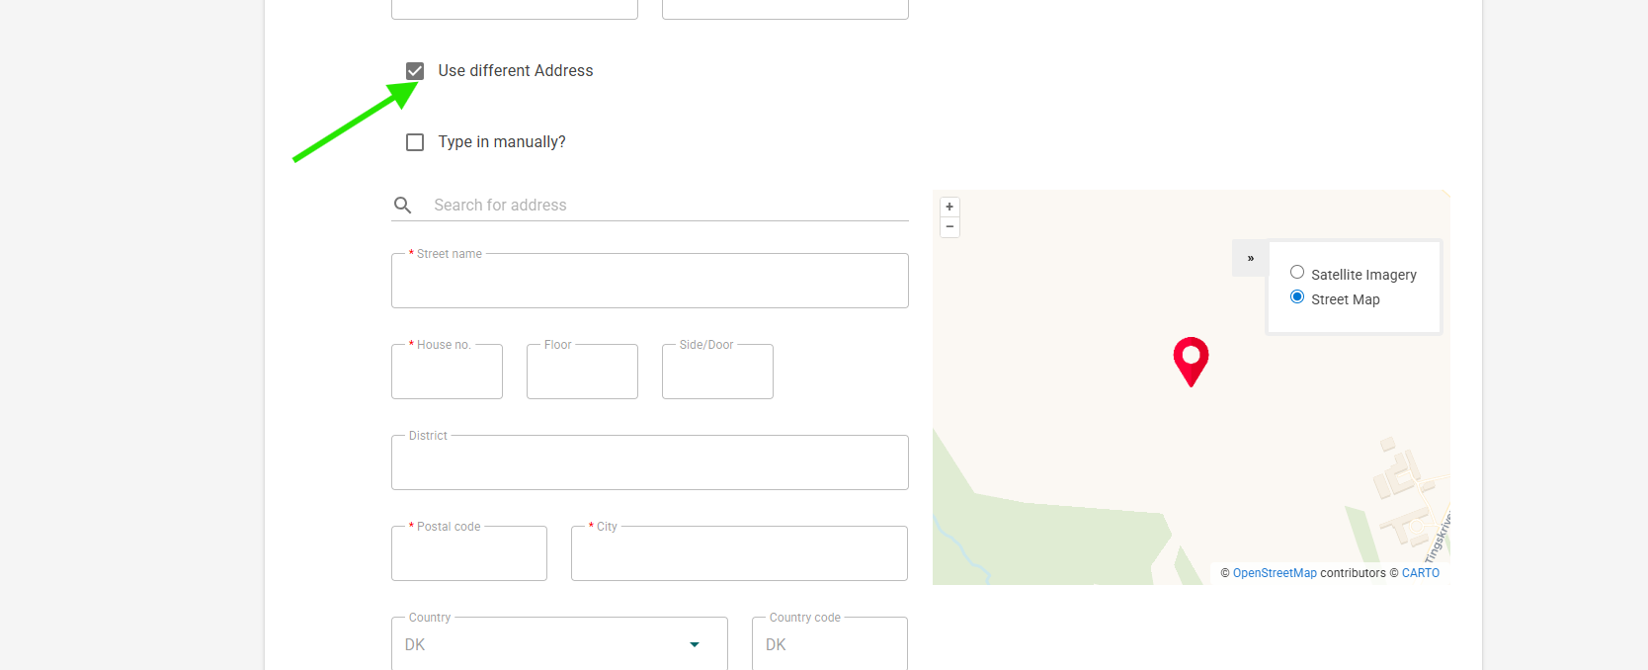
//User can also enter different connection fee paid by by clicking on check box
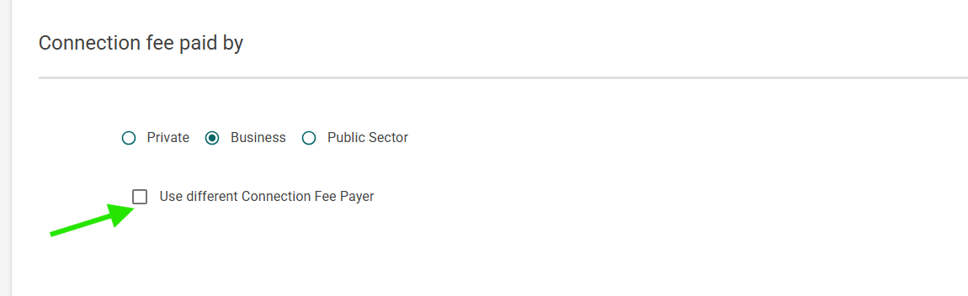
SERVICE LINE AND TECHNICAL DETAILS
Enter the details for service line 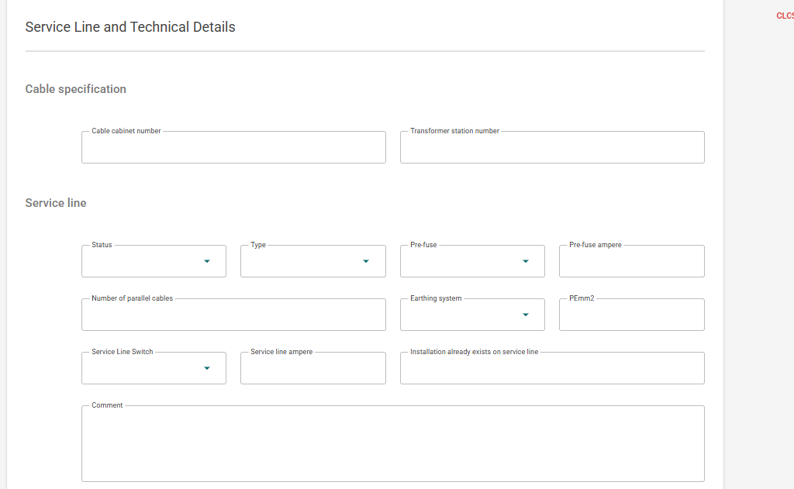

Meter and Utilization section
Enter the necessary details for meter section
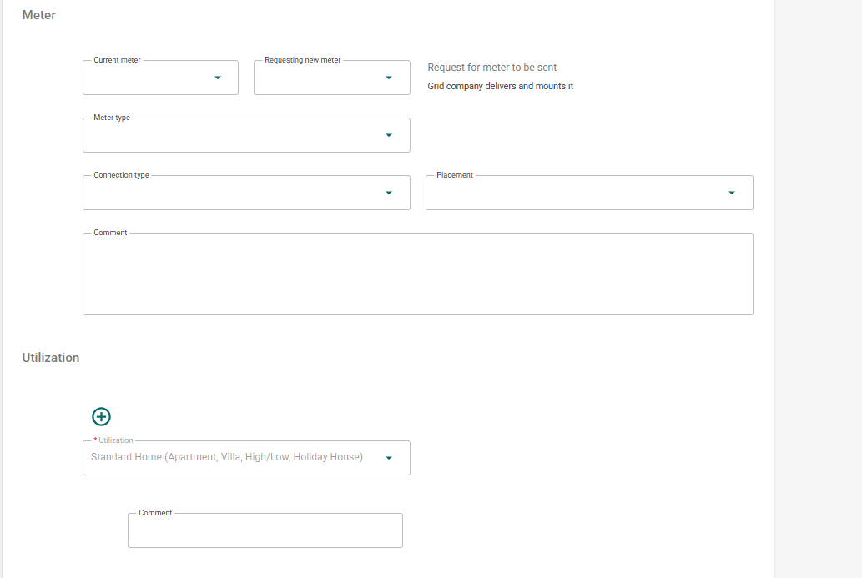
Note: User can add 'N' number of utilization details based on consumption category.
After filling in all the mandatory details for the New Installation Form, the user can click on Save or Send.
Click on Send → Work order request submitted successfully [Where new work order request goes to Sonwin]
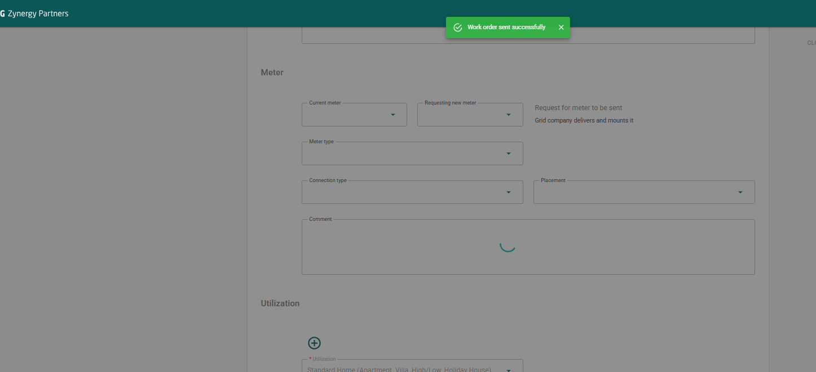
// SONWIN FLOW
Login to Sonwin Application
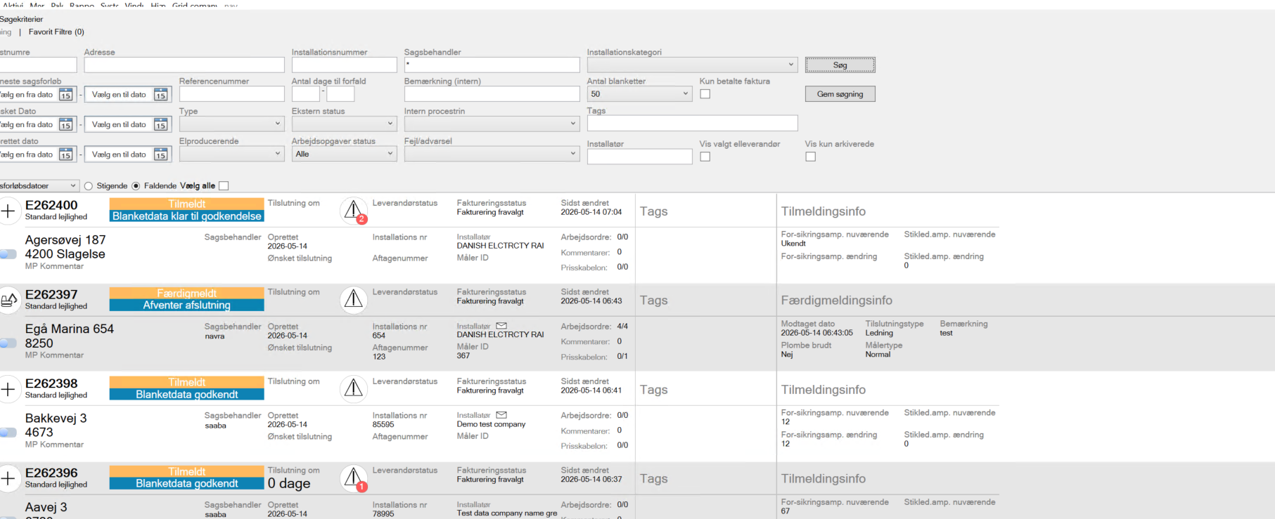
Click on the record which you submitted
Fill in all the details and Godkend the application
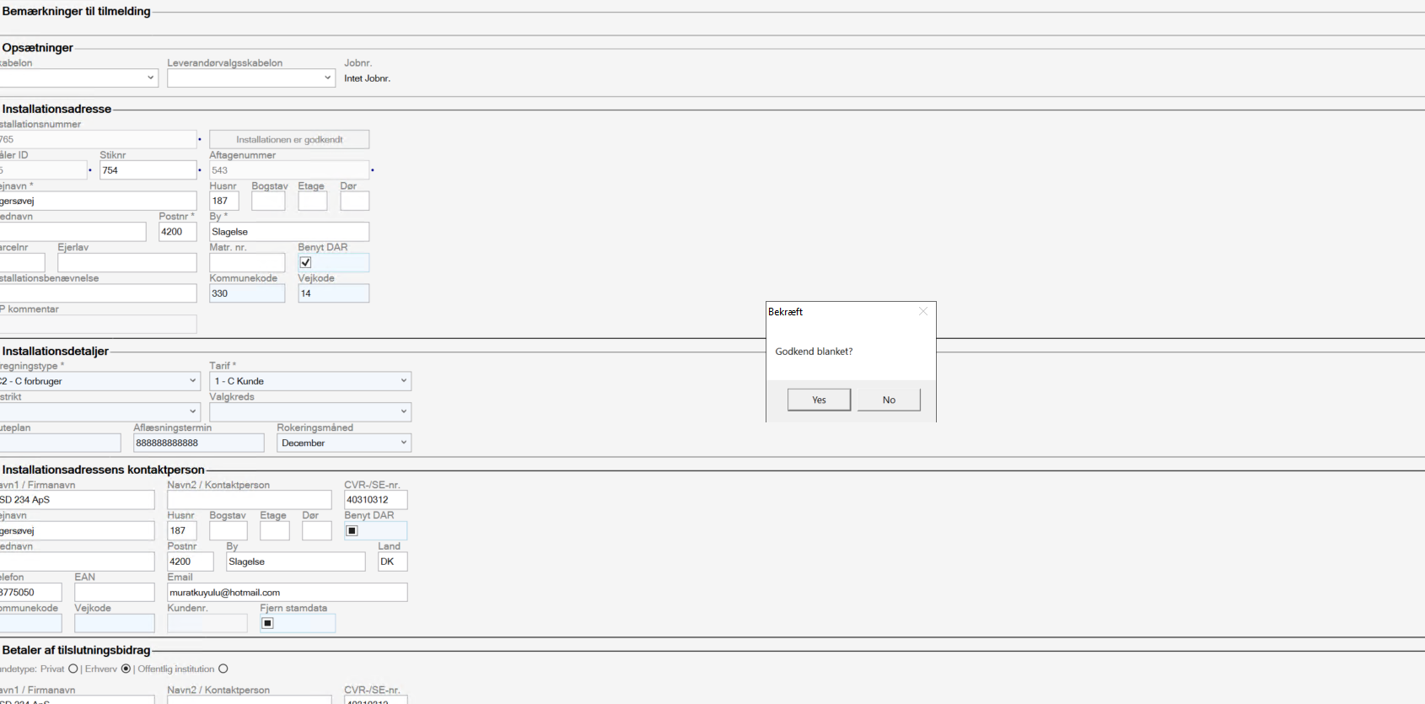
Note : Grid User can perform the cancel, finish the workorder at any state
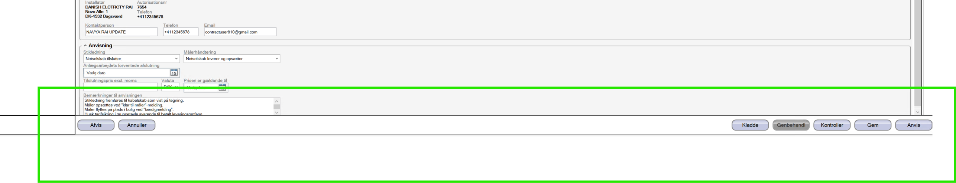
Send the instruction to Partner portal – Click on Yes
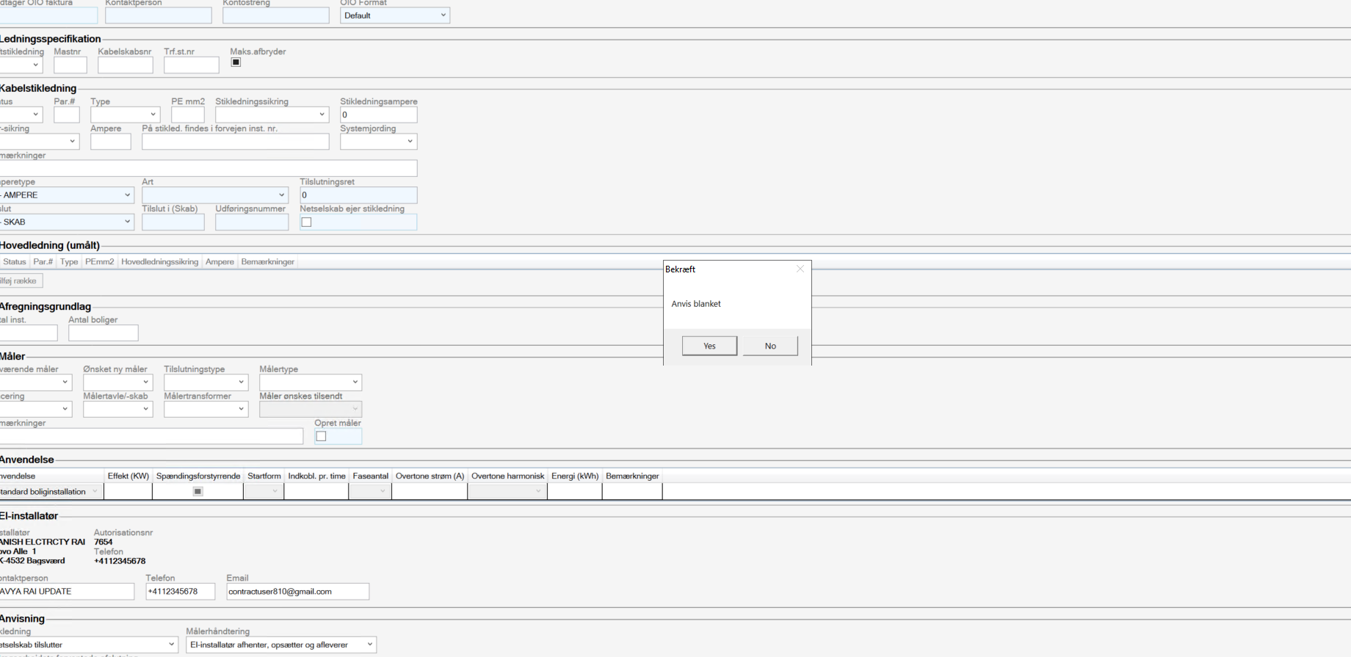
Once the instruction is received, log in to the Zynergy Partner Portal. Work order status will be in Instruction Received. 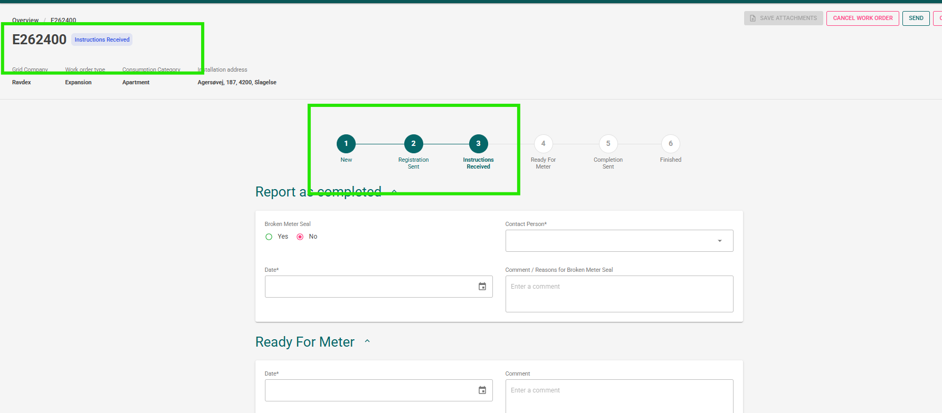
Note: You can cancel the work order during the Instruction Received status.
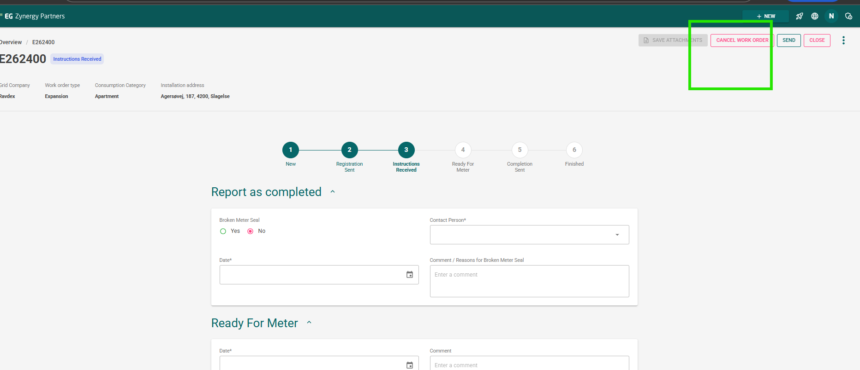
// Once the instruction received – Fill in the details For Ready for Meter and complete the form
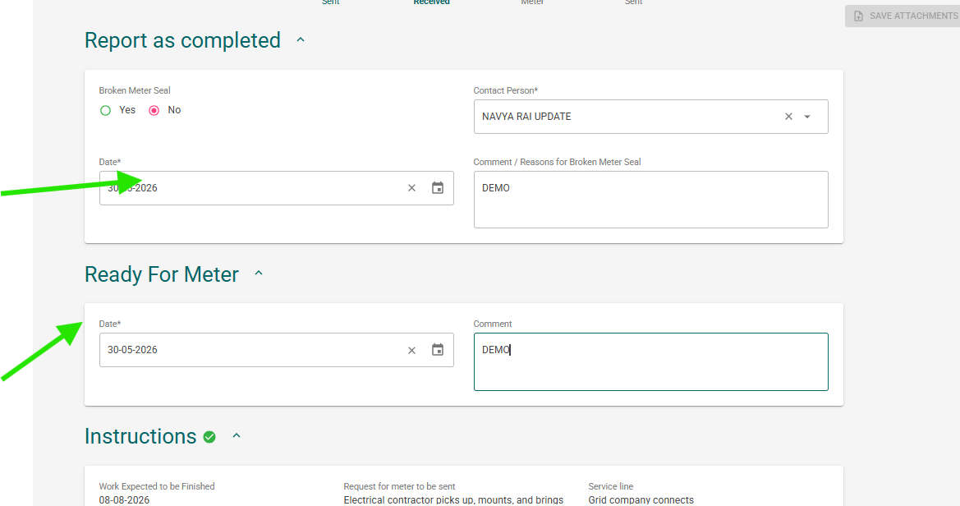
After filling the details – click on Send
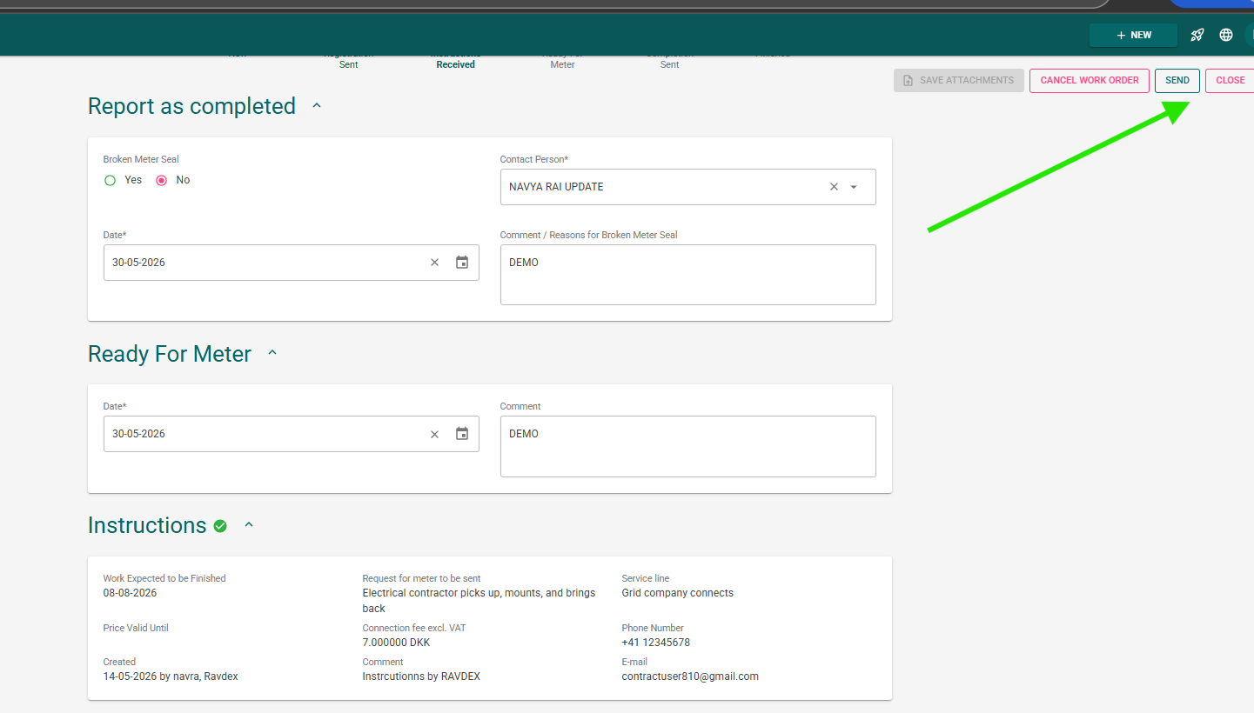
Work order details sent to Sonwin and the status gets Completed. 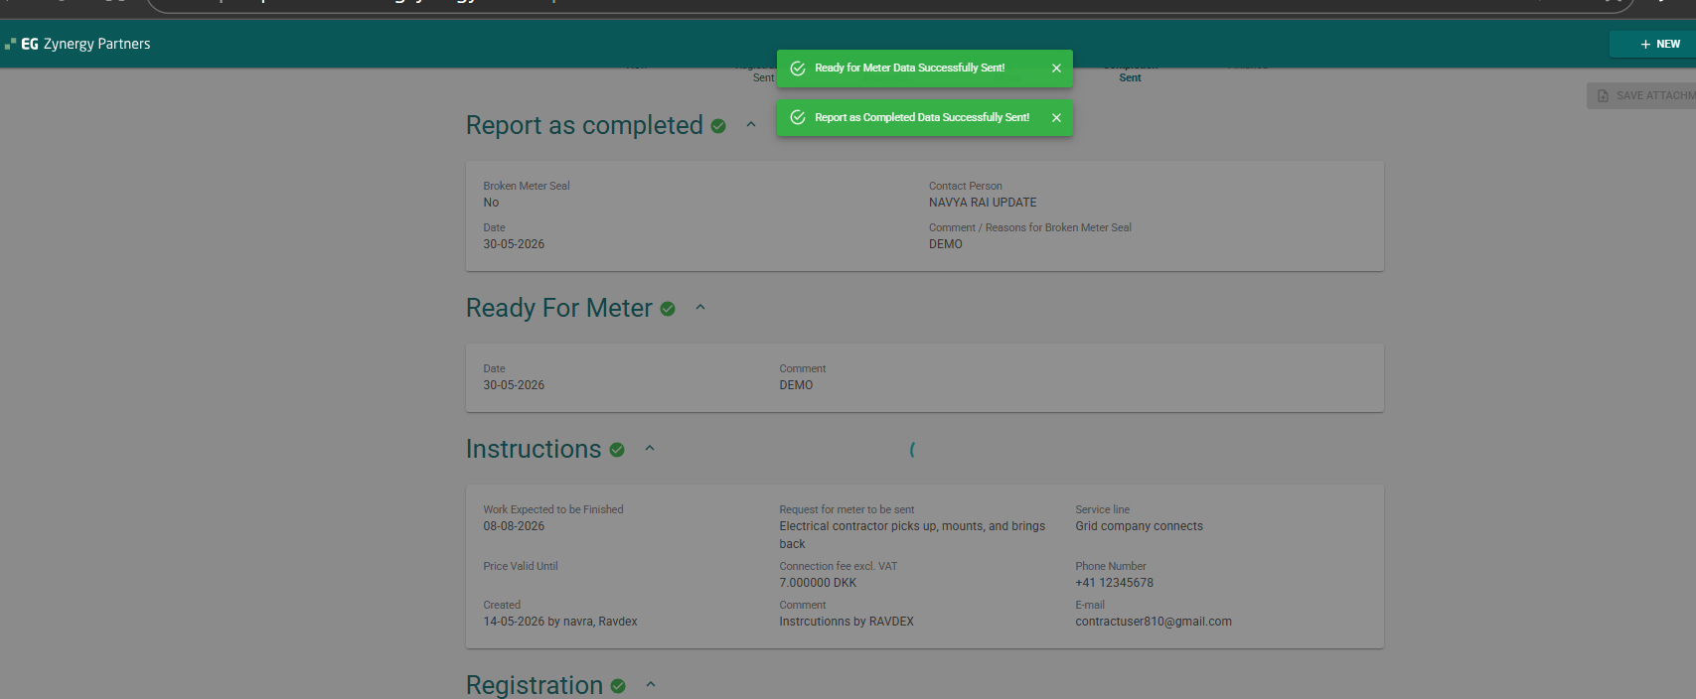
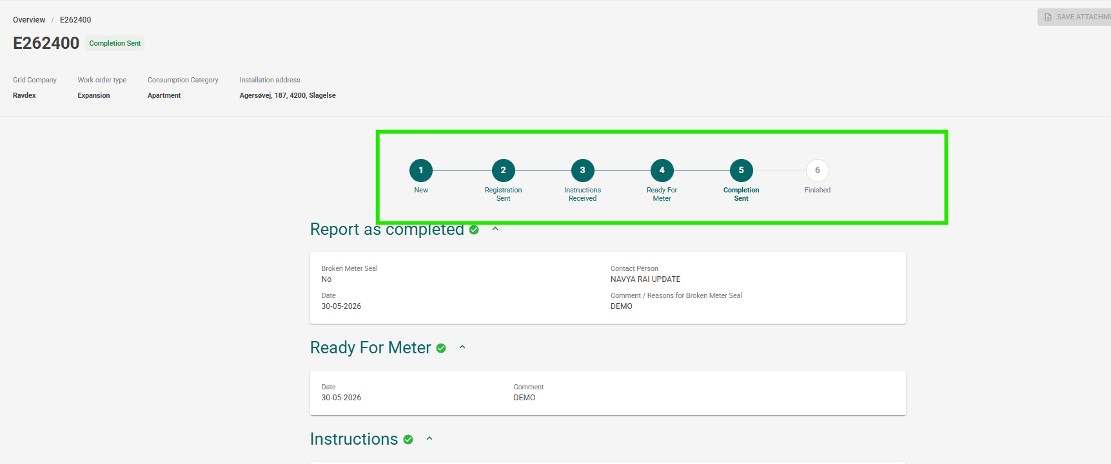

//Sonwin Application: Click on the work order number – Grid user can Finish / Cancel / Reject the request.
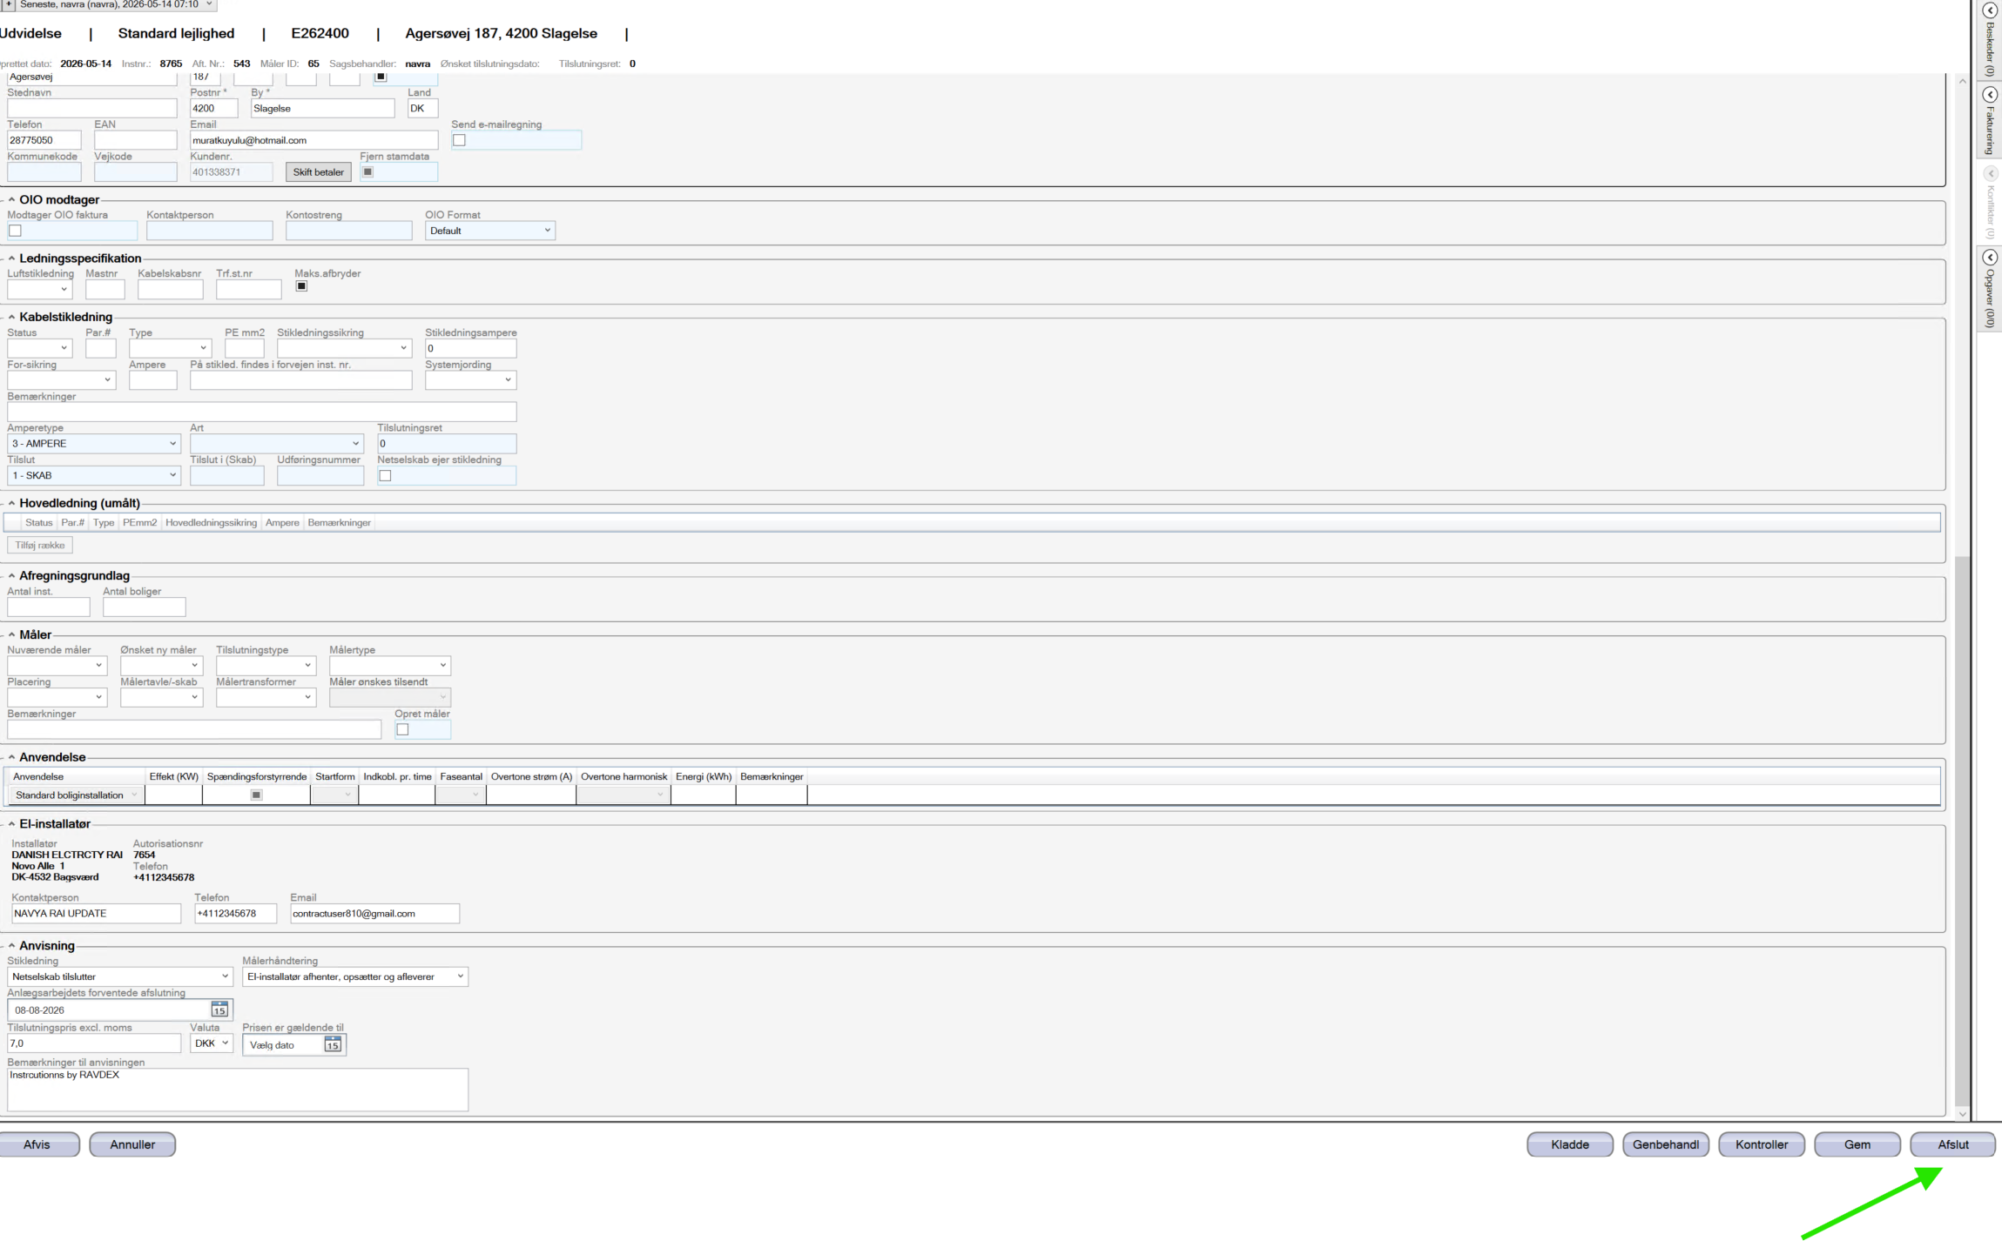
Finish the work order request by clicking on Afslut.
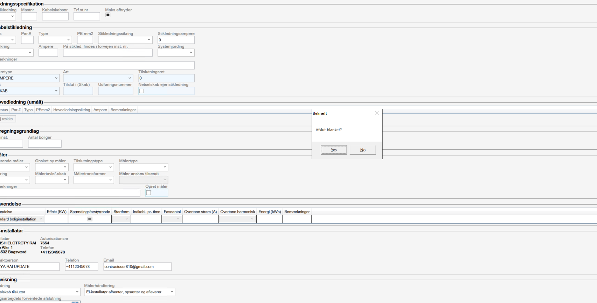

// Login to the Zynergy Partner Portal – Work order will be in Finished status.
